Process After Data Extraction
Data Cleaning and Averaging
After extracting the raw spectral readings from the AS7263 sensor, the system performs data cleaning to remove invalid or incomplete values such as zero, negative, or missing channel readings. During the 3-second scanning duration, the sensor continuously measures all six NIR channels (R, S, T, U, V, and W) at 100-millisecond intervals. Each channel’s readings are accumulated and averaged based on the number of scans completed within that duration. This averaging process reduces random noise and produces stable, representative values for each channel. The result is a cleaned and averaged dataset ready for computation.
Model Computation
The averaged channel readings (R,S,T,U,V,W) are then sent via Wi-Fi from the ESP32 microcontroller to the backend API. The backend applies the Lasso Regression formula generated during model training, using the pre-defined coefficients and intercept values. Since the regression model was trained using raw averaged data, no normalization or scaling is performed at this stage. The computation follows:
[ Y = Intercept + (R × coef_R) + (S × coef_S) + (T × coef_T) + (U × coef_U) + (V × coef_V) + (W × coef_W) ]
This equation is executed separately for Brix and Pol prediction, each using its own coefficient set derived from training.

Computation of Derived Values
Once Brix and Pol are predicted, additional sugarcane quality parameters are calculated based on standard
formulas: - Purity (%) = (Pol / Brix) × 100
- LKgTC = Brix × Recovery Coefficient (0.09)
- (Optional) Sucrose Content = Brix × (Purity / 100)
These computations translate the predicted optical measurements into meaningful agricultural indicators.
Output and Storage
The computed values (Brix, Pol, Purity, NIR Channels) are displayed on the device’s 3.5-inch TFT LCD for real-time viewing. Simultaneously, the data are transmitted and stored in the backend database through API, where they can be accessed and visualized in the mobile application for historical tracking and trend analysis.

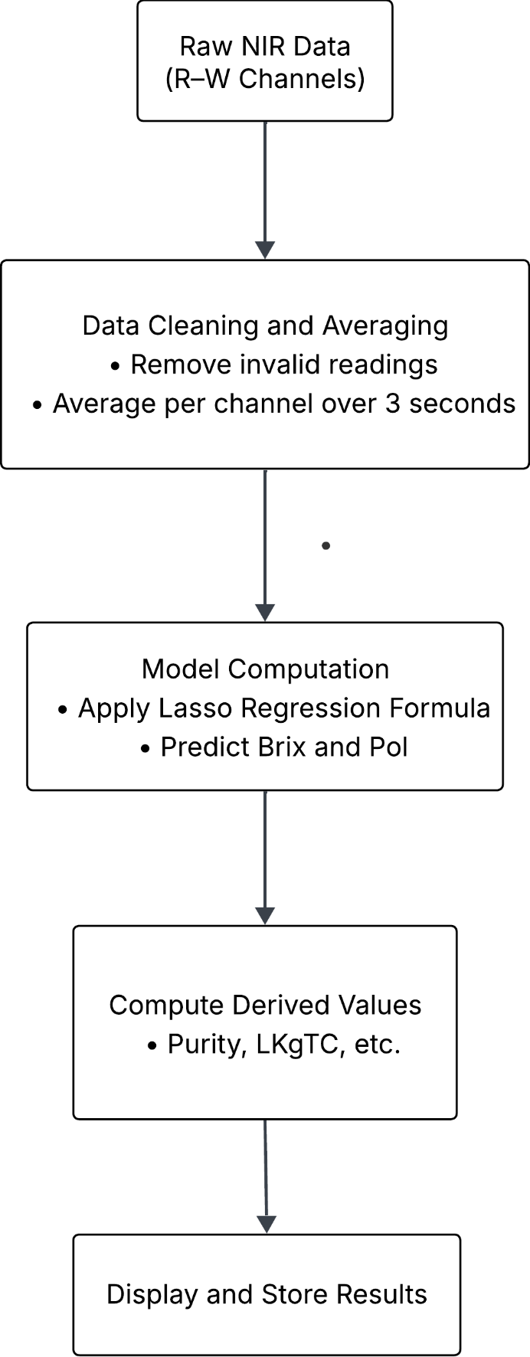
Summary Flow:

